**1. Open Below Link on browser**

<https://www.python.org/downloads/>

**2. click on Download Python 3.10.2 button**

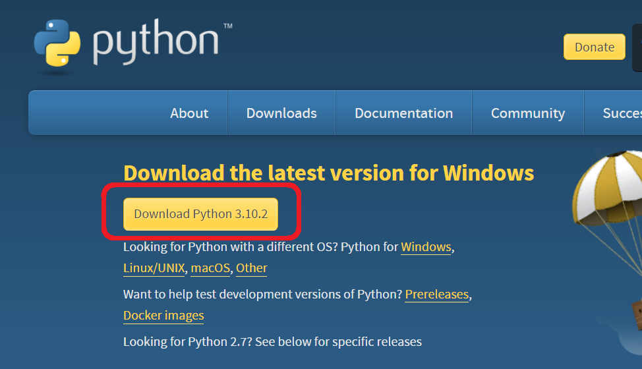

🡪It will download python-3.10.5-AMD64.exe file

🡪Double click on python-3.10.5-AMD64.exe file

* **Select Add python 3.10­ to PATH check box**
* Then Click on **Install Now**

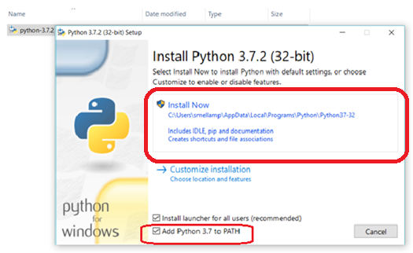

* Then Click on YES

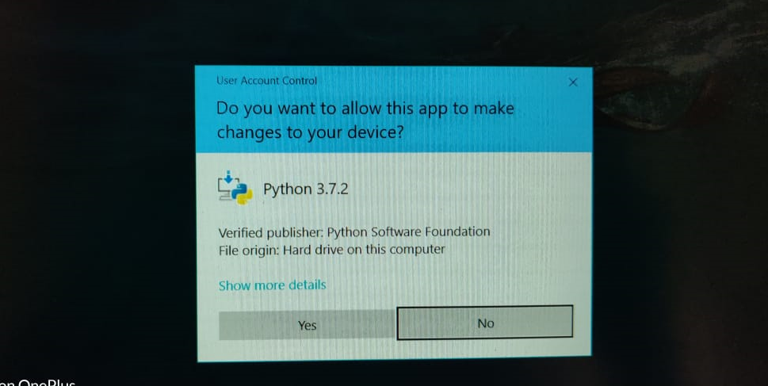

**INSTALLATION IN PROGRESS**

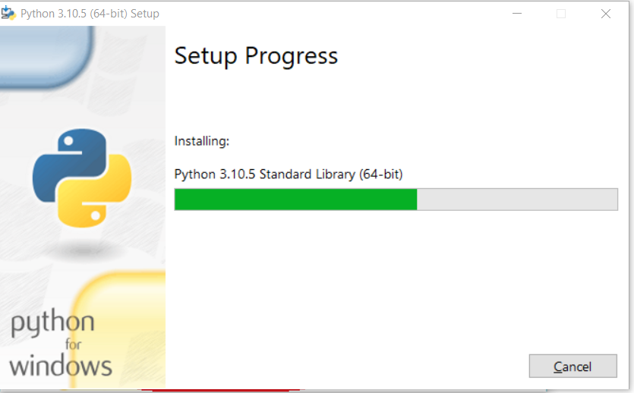

**INSTALLATION IS COMPLETED CLICK ON CLOSE BUTTON**

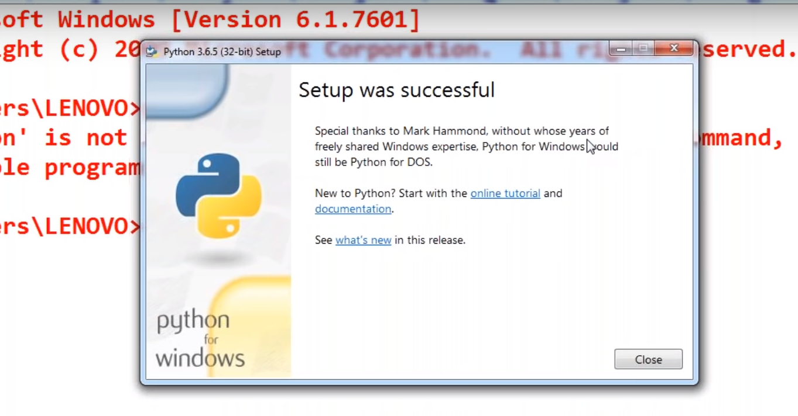

* Run below command in **CMD (command prompt)** to know python is installed or not

**python –V**

